Minimization of Inrush Current Using Reinforcement Learning
Anubhav Kumar Pandey
Department of Electrical & Electronics Engineering
Dayananda Sagar College of Engineering
Bengaluru, Karnataka, India
Member, IEEE
anubhav-eee@dayanandasagar.edu
Sujit Kumar
Department of Electrical Engineering
Amrita Vishwa Vidhyapeetham
Bengaluru, Karnataka, India k_sujit@blr.amrita.edu
Lekshmi S.
Department of Electrical Engineering
Amrita Vishwa Vidhyapeetham
Bengaluru, Karnataka, India s_lekshmi@blr.amrita.edu
Manitha P. V.
Department of Electrical Engineering
Amrita Vishwa Vidhyapeetham
Bengaluru, Karnataka, India
pv_manitha@blr.amrita.edu
A. Abhinaya Deepika
Department of Electrical Engineering
Amrita Vishwa Vidhyapeetham
Bengaluru, Karnataka, India
bl.en.u4elc24001@bl.students.amrita.edu
Prapthi Kandala
Department of Electrical Engineering
Amrita Vishwa Vidhyapeetham
Bengaluru, Karnataka, India
bl.en.u4elc24017@bl.students.amrita.edu

G. Manikanta
Department of Electrical & Electronics Engineering
Dayananda Sagar College of Engineering
Bengaluru, Karnataka, India
gopisetti-eee@dayanandasagar.edu

Abstract—Transformer energization produces high magnetizing inrush currents due to residual core flux and nonlinear magnetic characteristics. These currents cause mechanical stress, insulation aging, false relay tripping, and power quality disturbances. Conventional mitigation approaches such as controlled switching and prefluxing rely on accurate residual flux estimation and precise timing, which limits their reliability under practical operating uncertainties. This paper proposes a Reinforcement Learning (RL) based controlled switching strategy to minimize three-phase transformer inrush current by selecting an optimal closing angle. A nonlinear MATLAB model including leakage inductance, winding resistance, saturation, and multiple residual flux scenarios is used to imitate a realistic transformer behaviour. A Q-learning agent is trained to select optimal closing angle using reward based on minimizing peak per-unit current. The proposed method provides adaptive energization control strategies.
Keywords—Q-learning, power transformers, controlled switching, reinforcement learning, inrush current.
Ⅰ. Introduction
Power transformers play a very important role in the modern power systems, and their stable functioning is the backbone of the stability of the systems, and the quality of electricity.
During energization, transformers often experience a high transient magnetizing current, known as inrush current, caused by residual core flux and the nonlinear magnetizing behaviour of the transformer core. This current exceeds the rated-current value by several factors, which can result in unwanted effects of mechanical stress in windings, insulation degradation, higher electromagnetic force, and malfunction of differentiation protection designs [5,15].

As a result, minimization of transformer inrush current has been a long term and important research concern in power system engineering.
To reduce inrush current, several strategies have been suggested over the years. Controlled switching and optimal selection of the energizing angle has also proven to be promising and is being used to optimize transient performance by prefluxing the transformer around flux zero-crossing or by closely selecting voltage instants [1,3]. To further optimize transient performance, prefluxing methods and practical methods and practical issues of implementation have been explored [7]. Mitigation strategies can be supported by experimental and measurement-based validations of the feasibility of those strategies using real transformer systems [4,10]. But most traditional controlled
switching methods demand both very accurate residual flux estimation, and extremely fine-tuned synchronization hardware, predictable model assumptions and tend to fail to adapt to uncertain operating conditions, switching delays, or different residual magnetizing conditions.
As the techniques of intelligent control have improved, Reinforcement Learning (RL) has become a solution which is able to learn an optimal control choice through interactions with the environment without directly modeling the system. The adaptive learning ability and efficiency of decision making have proven to make RL very promising in complex and non-linear power system control applications [11,12]. Recently an attempt has been made to consider RL as a candidate to reduce inrush in transformers, in which case RL agents are conditioned to decide how to energize or not energize at different points to make inrush currents more limited [6,14]. The improved Q-learning techniques are enhanced RL algorithms that support the validity of applying intelligent learning-based optimization in these dynamic applications even more [13]. Nevertheless, the current state of research in the domain of RL-based Transformer inrush current suppression remains at the initial level of the research, and additional studies are required to create strong frameworks that can be used in practice.
Inspired by these observations, this paper suggests a Reinforcement Learning informed method of minimizing transformer inrush current, to obtain adaptive energization control without depending on accurate residual flux calculation or switching policies. Here the RL is exploited by the proposed strategy to learn the optimal policies by interacting with a simulation environment that is modelled based on nonlinear transformer magnetic properties. The efficiency of the technique is measured by determining the level of inrush prior to the application of RL based control and after its application.

Ⅱ. Literature Review
Transformer inrush current has been a research issue of significant interest over the past decades due to its significant impact on the reliability of the power system, aging of transformers and the coordination of protection. In general, the existing literature can be divided into (i) traditional methods of controlled switching and (ii) new methods of intelligent learning, in particular, Reinforcement Learning (RL). This segment critically evaluates the key contributions in the two areas and forms the research gap that still exists in this work.
A. Traditional Transformer Inrush Reduction methods.
Previous studies mainly concentrated on developing energization techniques to reduce the asymmetry of flux since the degree of inrush directly depends on the degree to which the magnetic core flux tracks its steady state path throughout the switching process. Optimal energization angle determination is one of the frequently studied techniques, and switching instants are calculated to minimize the initial flux offset. Cho et al. showed a refined energization angle technique that showed a substantial decrease in maximum magnetizing current of three-phase transformers [1]. Likewise, Mitra et al. examined real world applications of controlled switching in a utility environment and emphasized that it is viable in industrial applications [3].
Additional innovations provided prefluxing-based methods, in which the core of the transformer is pre-magnetized before charging with current to neutralize the effects of residual flux. Pan et al. used prefluxing together with controlled switching, stating improved robustness under operating conditions of variations [2].In other studies, the effect of switching resistance, residual magnetism uncertainty and breaker properties were also considered and provided more understanding of the behavior of practical energization [7].Flux error based methods, also, have been devised to dynamically coordinate flux paths in closures, which in effect cuts inrush peaks [9].
Besides analytical and simulation-based works, a number of works proved these methods experimentally. The measurement-proven inrush reducing strategies of Dy-connected transformers were released and made by Łukaniszyn et al., with the focus on the applicability to actual installations [4].The authors stressed that proper establishment of residual flux and proper determination of energization instants is a key factor to successful implementation [10], other researchers experimented with the energization using AC voltage controller to reduce excitation bursts [8].Although these traditional techniques are technically correct and proved to be effective, they are highly sensitive to accurate determination of residual flux, determination of voltage phase, precision in breaking synchronization, deterministic modelling and ideal condition of the system. Uncertainties include the noise in measurements, the response of the breakers, disturbances in the system and unpredictable residual magnetism which reduces the reliability in real power systems. Such constraints encourage the change towards smarter, adaptable, and information-driven control methods.

B. Intelligent Approaches
Since artificial intelligence has evolved, Reinforcement Learning has been viewed as a promising measure to control and optimize the power system and make autonomous decisions. The use of RL is especially appealing, given that the agent is not needed to possess specific analytical rules on how to switch between behaviour modes, but rather, it learns how to perform optimally by playing with the system, which is suitable to adapt to nonlinear, uncertain, and dynamic environments [11,12]. Recent studies have initiated extrapolating the concept of RL to transformer energization. Ugarte-Valdivielso et al. designed transformer simulation models to test RL-based inrush reduction strategies and established that RL agents can learn closing choices that result in reduced inrush currents than arbitrary switching [6].
Another more modern work proposed a controlled switching approach based on RL, which explicitly aims at inrush reduction, and the study boasts of better performance than traditional analytical schemes[14].Besides, the progress of Q-learning improvements, policy-gradient methods, and hybrid meta-heuristic aided RL algorithms enhance convergence and stability of RL solutions[13].
Machine learning techniques have also been incresingly adopted in power systems, and fault prediction applications.advanced supervised learning models, including Support vector Machines,Random Forests, and decision trees,have showed high accuracy in detecting and classiying electrical faults in transmission systems improving system reliability through data-driven decision making[16].Similarly, machine learning based fault distance estimation approaches have been developed for underground transmission networks using impedance relay data,where algorithms such as K-Nearest neighbors, Support Vector Regression, and Artificial Neural Networks achieved good accuracy compared with conventional analytical methods[17].
The integration of Internet of Things(IOT) technologies with intelligent analytics has further enhanced transformer monitoring capabilities. IoT-based transformer health monitoring systems emplying distributed sensors and cloud platforms enable continuous observation of operational parameters and early fault detection, supporting the predictive maintenance strategies in modern power grids [18]. In addition, mahine learning approaches have been applied specifically to transformer condition monitoring, where multiple classification lgorithms were utilized to predict faults such as magnetic oil gauge abnormalities using long term sensor data [19].These developments collectively demonstrate the growing potential of intelligent and adaptive techniques in improving the transformer operation, monitoring and protection.

- Research Gap
Based on the literature it is clear that whereas traditional controlled switching, prefluxing, and flux-based control measures are effective in reducing transformer inrush current, they are inherently relying on accurate system information, accurate hardware implementation and strict deterministic requirements. They are not flexible in an environment of uncertainty. On the othe rhand,although machine learning and IoT-based monitoring approachings have demonstrated strong performance in fault detection, condition monitoring, and system prediction [16]-[19], their application to transformer energization control and inrush minimization remains limited.
Even though such solutions as RL-based energization have potential, they remain still in their initial development stage and need thorough verification with realistic nonlinear transformer models and different scenarios with residual flux sources. Consequently, the proposed work is an energization control method, based on Reinforcement Learning, that is capable of independently learning the best breaker closing angles, and that implicitly accounts for nonlinear magnetization effects, as well as residual flux uncertainty.

Ⅲ. Methodology
The suggested methodology combines a nonlinear model of three-stage transformer energization with a decision-making structure based on Reinforcement Learning (RL) to reduce inrush current to a minimum. Overall development will include the nonlinear transformer modeling, RL environment construction, defining the reward, Q-learning and convergence and policy extraction with performance evaluation.

Nonlinear Transformer Modelling Framework
The concept of this research is based on the following three-step transformer modeling framework that is nonlinear. A nonlinear time-domain transformer model was formulated in MATLAB to precisely recreate the electromagnetic characteristics of inrush current in the process of energizing a circuit. The system is associated with a 7.4-MVA, 30/20 -kV, 50-Hz three-phase transformer, which is modeled in the abc frame. Each transformer phase is made up of winding resistance, leakage inductance, nonlinear magnetizing branch, and initializes residual flux, and a controllable source closing angle. The model presented of such an approach is in line with well-known transformer energization and inrush current analysis models in the literature [4,5,15].
The inrush current mainly depends on the transformer core flux at the instant of energization. Therefore, the modelling focuses on the applied phase voltage, the winding impedance drops, flux evolution in the core and nonlinear saturation effects. The three phase source voltages are expressed as sinusoidal waveforms shifted by the breaker angle $θ_{c}$. Due to energization at different $θ_{c}$ it results in different initial core flux trajectories. The instantaneous phase voltages applied to the transformer windings including the breaker closing angle are shown in the equations (1,2,3).
$V_{a}=\frac{\sqrt{2}V_{LL}}{\sqrt{3} sin(wt+θ_{c})}$ (1)
$V_{b}=\frac{\sqrt{2} V_{LL}}{\sqrt{3} sin(wt+θ_{c}− \frac{2π}{3})}$ (2)
$V_{c}=\frac{\sqrt{2} V_{LL}}{\sqrt{3} sin(wt+θ_{c}+\frac{2π}{3})_{}}$ (3)
Where ω=2πf is the angular frequency and 𝜃_{c} is the RL selected breaker closing angle.This formulation aligns with controlled switching which are widely used [2,3,9].
Before voltage excites the core, some of it is lost across the winding resistance (R) and leakage inductance (L). The leakage path and copper losses, which influence the transient current shape in the equation (4).
$V_{ik}(t)=Ri(t)+L\frac{di(t)}{dt}$ (4)
The equation (5) indicates voltage that actually drives core flux is the remaining voltage applied across the magnetizing branch
$V_{core}(t)=V_{phase}(t)−V_{ik}(t)$ (5)
Transformer core flux is related to induced voltage. Hence, the core voltage is obtained by differentiating the core flux as shown in equation (6).
$V(t)=\frac{dϕ(t)}{dt}$ (6)
which is numerically implemented in discrete form as
$ϕ(t)=ϕ(k−1)+V_{core}(k)Δt$ (7)
The equation (7) captures flux build up and DC offset, which is the primary cause of large inrush currents when saturation occurs. To represent realistic core saturation, a nonlinear flux dependent magnetizing inductance is expressed as shown in the equation (8).
$L_{m}(ϕ)={L_{m,nom}(1−α_{sat}tanh(\frac{ϕ}{ϕ_{sat}}))}_{}$ (8)
which ensures a high inductance under unsaturated conditions and reduced inductance under saturation. The instantaneous magnetizing current is computed as shown in equation (9).
$i_{m}(t)=\frac{ϕ(t)}{L_{m}(ϕ)}$ (9)
For each energisation the peak current of all phases is recorded, and the highest magnitude is considered as the inrush severity index. Currents are expressed in per unit using equation (10).
$I_{base}(t)=\frac{S_{base}}{\sqrt{3} V_{LL} {}_{}}$ (10)
This nonlinear model has managed to replicate major characteristics of transformer inrush such as asymmetric flux accumulation, DC offset content, large transient peaks, and smooth stabilization and has therefore served as a solid foundation of RL-based development of energization strategies, which is consistent with the behaviour seen in [4,5].

B. RL Environment Formulation
Uncertainties that are considered practical in the RL environment are those relating to transformer energization, which are mostly due to residual magnetic flux and the de-energization history [1,2,10]. Two dominant factors are used to construct the state space, namely breaker opening angle and residual flux pattern. There are 12 open angles between that are discrete 0∘ and 330 º in steps of 30∘ are taken with five typical three phase residual flux combinations, that is, balanced, partially unbalanced, and severe saturation, making a total of 60 different states. The breaker closing instant is in the action space, which is discretized amongst 0∘ and 359∘ in steps of 5∘, yielding 72 possible actions. This formulation offers adequate fine control over the resolution of energization as well as remaining computational feasible. The use of RL as the control model is based on its capacity to learn ideal switching behaviour in an adaptive manner without residual flux measurement as used in the recent literature that points out to RL potential in power system decision-making and transformer energization control [6,11,12].

C. Reward Design
The reinforcement learning model is designed in a way that the agent directly learns to reduce severity of transformer inrush. In all the energization simulations, the maximum magnetizing currents of the three phases are assessed and the largest of these currents are per-unit with reference to the transformer base current. This value is negated to define the reward in such a manner that large inrush magnitudes are associated with a very negative reward, and lower inrush magnitudes with a relatively large reward, as shown in the equation (11).
$R=−max(I_{a},I_{b},I_{c})$ (11)
As the energization of the transformer involves only one switching act, the learning problem is represented as a one-step episodic RL task. This kind of reward structure will automatically drive the agent to energization angles that inhibit the current peaks. The Fig.1, depicts that the transformer model serves as the environment and the RL agent acts as the decision-making unit. Based on the observed inrush current magnitude, the agent generates an optimal breaker closing angle, leading to reduced inrush current.

Transformer Model
RL Agent

Optimal Closing Model

Reduced Inrush Current
Fig.1. Block diagram of the proposed RL minimization method.
D. Q Learning Framework
The use of a tabular Q-learning algorithm is due to the discrete and finite state and action space. The use of Q-learning in the literature of power system control is due to its simplicity, stability and capability to learn without the use of system derivatives or explicit models [11, 12]. The initial stage involves zeroing all Q-values and learning is achieved with repeated agent environment interactions. A random operating state, consisting of a given opening angle and residual flux pattern is chosen in every episode. An
$ε$-greedy exploration policy is applied by the agent to choose a closing action to balance exploration and exploitation. This leads to an inrush response that is simulated through a nonlinear transformer model and reward is calculated according to the specified equation.

Using the Q-value of the executed state-action pair, the Q-value of the state-action pair is updated.
$Q(s,α)=Q(s,α)+α(R(s,α)−Q(s,α))$ (12)
In the equation (12) α is the learning rate. As the transformer energization is a single-decision issue, the discount factor has been set to γ=0. The amount of training is 5000 episodes, and it assures sufficient exploration of the full operating space and stabilization in the strategies of the energization. Once convergence has been trained, the last Q-table is the learned energization policy. The action that can be executed with the largest value of Q is the optimal closing angle to each operating state. The nonlinear transformer model is used to provide a systematic assessment of the policy in all the states and the peak inrush currents per unit are recorded. Policy maps and inrush heat maps are created in order to display learned choices and illustrate the alignment between RL-selected angles of switching and minimum-inrush areas. Time-domain waveforms are also analysed to confirm the enhanced flux symmetry, less transient peaks and smoother stabilization, which proves the practical inrush reduction in line with the results of RL-based transformer control available in literature [6,14].

TABLE Ⅰ Transformer Parameters
Parameter | Symbol | Value
Rated Power | $${S_{rated}}_{}$$ | 7.4MVA
Primary line voltage | $$V_{LL,HV}$$ | 30kV
Secondary line voltage | $$V_{LL,LV}$$ | 20kV
Frequency | f | 50Hz
Base current | $$I_{base}$$ | 142 A(approx)
HV Winding Resistance | $$R_{HV}$$ | 1.28Ω
LV Winding Resistance | $$R_{LV}$$ | 0.26 Ω
HV Leakage Resistance | $$L_{lk,HV}$$ | 81.12mH
LV Leakage Resistance | $$L_{lk,LV}$$ | 58.58mH
Saturation coefficient | $$α_{sat}$$ | 0.85
Flux Saturation Scaling | $$ϕ_{sat}$$ | 0.08 Wb
Simulation Time Step | dt | 50𝜇s
Simulation Duration | $$t_{max}$$ | 0.25 s
Residual Flux Initialisation | ϕr | Multiple 3-phase patterns
Closing Angle | - | RL - selected

Ⅳ. Results
The developed nonlinear transformer simulation framework was used to analyse the proposed RL-based strategy. The 5000 episodes ε -greedy exploration agent was trained, and the Q-table was extracted with the final table to have optimal closing angles of every condition and residual flux pattern. A comparison between the obtained RL-optimized closing angle with the inrush currents of maximum per-unit at the applied angle with those at uncontrolled energization was used to measure performance.

A. Learned policy visualization
A policy map was created to show the optimal breaker closing angle chosen by the RL-agent of every opening angle residual flux combination. As shown in Fig. 2, the map indicates clearly that organized patterns are not random selections of actions, which shows that the agent has managed to determine closing instants that are always associated with reduced inrush currents with respect to specific magnetic states. This gives the assurance that the agent has been able to learn useful correlations between system conditions and decision on energization.
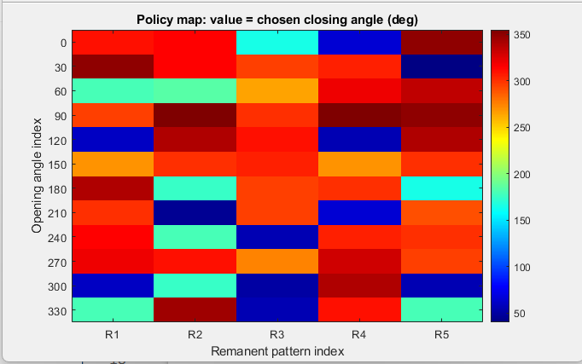
Fig.2. RL-based optimal closing angles under different energization conditions.
Also, an inrush heatmap was generated for a fixed remnant flux pattern by sweeping all the available closing angles. As shown in Fig. 3, the inrush magnitude varies with the closing angle, forming alternating low-inrush and high-inrush regions. The agent selects switching instants lie close to local minima regions of the heat map.
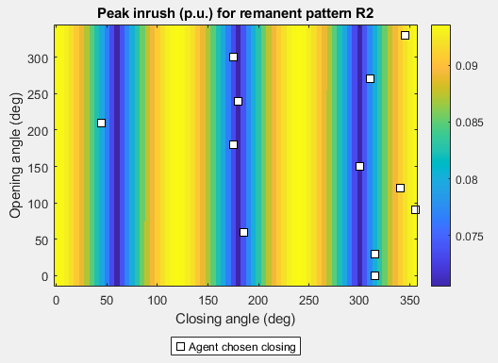
Fig.3. Inrush current heatmap versus opening and closing angles.
As this observation shows, the RL agent always approaches near optimal energization instants, which instinctively reduce the effects of core saturation, which agrees with the physical interpretation of inrush current formation achieved in [5,10]. The fact that the decision of RL is associated with low-inrush regions justifies that the policy of the agent is not a product of number training.

Response of Time Domain Energization
The transient nature of phase voltages, magnetizing current, and core flux was studied by analysing the corresponding time-domain waveforms energized by RL control. As shown in Fig. 4, the RL-controlled switching results in lower peak magnetizing current, improved phase symmetry, reduced saturation severity, and faster decay of transient oscillations.
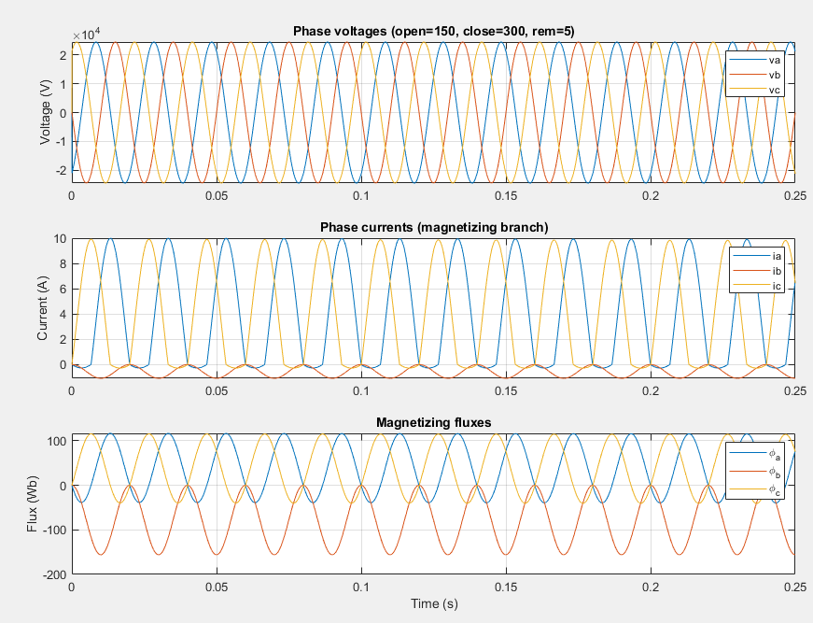
Fig.4. Time domain phase current and flux during RL-based energization.
These properties are in line with the ultimate objectives of mitigation of inrush reported in controlled switching and prefluxing based strategies [4]. The findings reveal that RL managed energization is effective in reducing the flux overshoot of energization at the start of energization, and hence it suppresses excessive magnetizing current.

Discussion

As opposed to analytical or deterministic controlled switching methods [1,2,7] , RL-based strategy builds learning of energization behaviour exclusively through engagement with the surrounding environment and no longer requires accurate estimation of residual flux or fixed switching computation equations. The agent automatically adapts to varying flux conditions and energization backgrounds.Moreover, RL has similar or better performance compared with standard optimizing switching strategies and provides the flexibility to be extended to more complex systems, noisy measurement systems, and hardware implementation conditions. Such results are consistent with the reported benefits of RL to power systems [6,12].

Ⅴ. Conclusion
This paper introduced a Reinforcement Learning (RL) based energization strategy to reduce three phase power transformer magnetizing inrush current. To obtain real-world energization behaviour, a nonlinear model of MATLAB time domain transformer operation incorporating winding resistance, leakage inductance, saturation properties and several residual flux conditions are created. A Q-learning agent was trained to determine the optimal breaker closing angle under different operating conditions influenced by breaker opening angles and residual flux patterns.

The obtained results demonstrate that the RL agent successfully learns optimized closing angles rather than random actions. The learned switching angles always coincide with regions of low inrush in inrush heat maps.
Time-domain waveform verification further confirms the reduction in peak magnetizing current, improved flux symmetry, and faster settling of transients. Overall, the proposed RL approach provides an adaptive and effective alternative to controlled switching methods.

ⅤI. Future Scope
The proposed reinforcement learning based transformer energization method has shown effective reduction of inrush current under simulated conditions. The developed algorithm can be implemented on a real- time hardware platforms such as microcontrollers, DSPs, and PLCbased controllers in future scope. Its performance can then be validated under practical operating conditions. The model can be further improved by incorporating realistic constraints including circuit breaker closing time and noise present in measurement signals, which will increase the reliability. In the present study the breaking closing angle is selected from a limited set of actions. This work can be extended to continuous action space reinforcement learning approaches to achieve more accurate and flexible switching control. In addition, the advanced learning techniques such as deep reinforcement learning can be explored to improve learning speed, convergence and generalization capability. The proposed technique can be applied to transformers of different ratings, configurations and loading conditions to evaluate its scalability. The reward function can also be modified and can also be changed according to the application. Strategies of online learning can be explored, in which the agent adjusts its policy to the feedback of real-time system responses, the approach is flexible to adaptive and intelligent manipulation of the power system.

Acknowledgment
The Authors would like to thank their respective institutions for carrying out this research work.

References

[1] J. -S. Cho, S. -J. Park and S. -K. Lim, "Inrush Current Reduction of Three-Phase Transformers Using Optimal Energization Angle Control," in IEEE Access, vol. 13, pp. 203183-203194, 2025, doi: 10.1109/ACCESS.2025.3638872.
[2] Y. Pan, X. Yin, Z. Zhang, B. Liu, M. Wang and X. Yin, "Three-Phase Transformer Inrush Current Reduction Strategy Based on Prefluxing and Controlled Switching," in IEEE Access, vol. 9, pp. 38961-38978, 2021, doi: 10.1109/ACCESS.2021.3062143.
[3] J. Mitra, X. Xu and M. Benidris, "A Controlled Switching Approach to Reduction of Three-Phase Transformer Inrush Currents," 2018 IEEE Industry Applications Society Annual Meeting (IAS), Portland, OR, USA, 2018, pp. 1-7, doi: 10.1109/IAS.2018.8544470.
[4] Łukaniszyn, Marian, Łukasz Majka, Bernard Baron, Barbara Kulesz, Krzysztof Tomczewski, and Krzysztof Wróbel. "Measurement Verification of a Developed Strategy of Inrush Current Reduction for a Non-Loaded Three-Phase Dy Transformer." Energies (19961073) 17, no. 21 (2024).
[5] Nițu, Maria-Cristina, Ileana-Diana Nicolae, Livia-Andreea Dina, and Paul-Mihai Mircea. "Power Transformer Inrush Current Analysis: Simulation, Measurement and Effects." Applied Sciences 14, no. 23 (2024): 10926.
[6] J. Ugarte-Valdivielso, M. Barrenetxea, A. Torres, B. G. Stewart and J. I. Aizpurua, "Power Transformer Modelling for the Evaluation of a Reinforcement Learning-Based Inrush Current Minimization Strategy," 2025 8th International Advanced Research Workshop on Transformers (ARWtr), BAIONA, Spain, 2025, pp. 24-29, doi: 10.23919/ARWtr66130.2025.11261306.
[7] D. Huang et al., "Research on Transformer Inrush Current Suppression and Optimal Closing Angle Considering Switching Resistance and Residual Flux," 2025 IEEE International Conference on Power Systems and Smart Grid Technologies (PSSGT), Chongqing, China, 2025, pp. 54-60, doi: 10.1109/PSSGT64932.2025.11034225.
[8] A. A. Rachman, Y. C. Arif and L. P. S. Raharja, "Inrush Current Limiter in 3-Phase Transformer Using AC Voltage Controller Simulation Using SIMULINK®," 2020 International Conference on Technology and Policy in Energy and Electric Power (ICT-PEP), Bandung, Indonesia, 2020, pp. 156-161, doi: 10.1109/ICT-PEP50916.2020.9249950.
[9] P. Pachore, Y. Gupta, S. Anand, S. Sarkar, P. Mathur and P. K. Singh, "Flux Error Function Based Controlled Switching Method for Minimizing Inrush Current in 3-Phase Transformer," in IEEE Transactions on Power Delivery, vol. 36, no. 2, pp. 870-879, April 2021, doi: 10.1109/TPWRD.2020.2995519.
[10] Petrović, Goran, Tomislav Kilić, and Stanko Milun. "Remanent flux measurement and optimal energization instant dertermination of power transformer." In XVII IMEKO World Congress Metrology in the 3rd Millennium. 2003.
[11] Glavic, Mevludin. "(Deep) reinforcement learning for electric power system control and related problems: A short review and perspectives." Annual Reviews in Control 48 (2019): 22-35.
[12] Bernadić, Alen, Goran Kujundžić, and Ivana Primorac. "Reinforcement learning in power system control and optimization." B&H Electrical Engineering 17, no. 1 (2023): 26-34.
[13] Li, Ying, Hanyu Wang, Jiahao Fan, and Yanyu Geng. "A novel Q-learning algorithm based on improved whale optimization algorithm for path planning." Plos one 17, no. 12 (2022): e0279438.
[14] Valdivielso, Jone Ugarte, Jose I. Aizpurua, Manex Barrenetxea, and Brian G. Stewart. "Reinforcement Learning-Based Controlled Switching Approach for Inrush Current Minimization in Power Transformers." arXiv preprint arXiv:2503.11398 (2025).
[15] L. -C. Wu, C. -W. Liu, S. -E. Chien and C. -S. Chen, "The Effect of Inrush Current on Transformer Protection," 2006 38th North American Power Symposium, Carbondale, IL, USA, 2006, pp. 449-456, doi: 10.1109/NAPS.2006.359611.
[16]D. Deepika, M. M. Charan, S. C. Nossam and P. V. Manitha, "Advanced Machine Learning Models for Electrical Fault Detection and Classification in Transmission Lines," 2025 3rd International Conference on Intelligent Data Communication Technologies and Internet of Things (IDCIoT), Bengaluru, India, 2025, pp. 1338-1341, doi: 10.1109/IDCIOT64235.2025.10914898.
[17]S. C. Mathi, P. N. Tammisettti, S. R. Akthar and M. P.V., "Machine Learning Based Fault Distance Estimation of Underground Transmission Using Impedance Relay," 2025 3rd International Conference on Intelligent Data Communication Technologies and Internet of Things (IDCIoT), Bengaluru, India, 2025, pp. 1472-1478, doi: 10.1109/IDCIOT64235.2025.10915170.
[18]C. Pathania, J. Vijay and M. P. V, "The IoT Solution for Reliable Transformer Condition Monitoring and Maintenance," 2023 8th International Conference on Communication and Electronics Systems (ICCES), Coimbatore, India, 2023, pp. 346-353, doi: 10.1109/ICCES57224.2023.10192711.
[19]A. Balan, S. T. L, M. P. V and K. Deepa, "Detection and Analysis of Faults in Transformer using Machine Learning," 2023 International Conference on Intelligent Data Communication Technologies and Internet of Things (IDCIoT), Bengaluru, India, 2023, pp. 477-482, doi: 10.1109/IDCIoT56793.2023.10052786.

